Laadli Grows Up

Have you noticed the Tanishq jewellery adthat flaunts adusky-complexioned mother of a five-year-old kid as a bride bejeweled; or the Bournvita ad in which a mother encourages her daughter to practice boxing and drink Bournvita to be physically fit; or the Havells fan ad in which the bridegroom announces at the time of his marriage that he will take his wife’s surname and not the other way round?Surprised at this sea-change in attitude – the atypical, progressive light in which women have been projected in these ads?
There are other such breakthrough changes happening in individuals, both men and women, in India, silently. Like till about a year back, Rita,a Bhopal-based journalist, would subtly encourage women through her writings, to be submissive in their behavior, following set patterns like walking with their heads bent low. However, that’s not so today. Gender-sensitized, Rita today frankly exhorts women to walk with their heads held high.
Rohini Bhosale, a TYBCom student in Mumbai, would always be wary of eve-teasing and bear it silently, albeit grudgingly, seeing it as an unavoidable bane of womanhood. However, participation in a street-play competition on the subject ‘Youth as agents of change,’ last year has emboldened Rohini and modified her views. Today, she knows that she can protect herself against eve-teasers and does not have to accept this menacemeekly.
Again, in the past, ace-homemaker and now one of Population First’s active staff Nita Khajuria would perform a zillion chores at home, always goaded by the insecurity that if she didn’t, she would not be liked. Today, she has completely shed those fears, respects herself, and does what she wishes to do, out of joy and love not fear.
These are but a few sparks of the blaze that the campaign Laadlitrailed in 2013, under the aegis of the NGO Population First that has been working for a “balanced, planned and stable population” since 2003. Conceived in 2004 as a reaction to the 2001 Census which revealed a steep fall in India’s sex ratio from 947 in 1991 to 927 in 2001, the Laadli campaign aimed to address the root of the problem of sex selection, which was people’s mind-sets- the overwhelming preference for sons , a preference that’s the product of regressive gender perceptions. If the human mind is the most potent force in this universe, it is also the most difficult to change, especially its tendencies that are deeply entrenched as veins in marble. How did Laadli intend to go about accomplishing this gargantuan task?
Says Dr.A.L.Sharada, Director of Population First “We decided that we would simply educate people on gender, i.e., the social and cultural definitions of man and woman; gender issues; and gender-sensitive behaviour.Gender awareness is generally low in India. We’d open up channels for people to talk, show them how we unconsciously promote gender stereotypes, and we would never be judgmental.” This methodology has determined the activities undertaken by Laadlisince its launch in June 2005, and proved to be its strength. “Subliminal communication is more important than on-the-face communication,” as Sharada succinctly puts it.
Comprehensibly, experience and time have teed off new ideas, expanding Laadli’s ambit of activities greatly. While the campaign started by dialoguing with the media and advertising industryto foster higher gender-sensitivity in the professionals peopling these spaces, today it has raced ahead to embrace schools, colleges, social media sites, literally the world with the support of United Nations Population Fund (UNFPA). In 2013, Laadli made significant leaps and can be said to have come of age. The activities in 2013 can broadly be classified into the following five areas:
- Varied workshops and other events with college students and teachers
- Gender Media workshops with journalists
- The Laadli media and Advertising Awards for Gender Sensitivity
- Work with the advertising industry
- Other stand-alone activities
Varied workshops and other events with college students and teachers
The slogan ‘Catch them young’ is relevant not just for selling any product but for the inception of any philosophy or attitude. And Laadli began to reach out to the youth through gender workshops in colleges. 2013 saw Population First hosting more thantwentygender workshops in different colleges in Mumbai; in each case, the workshops triggered off animated discussions among students on different gender issues like domestic violence, patriarchal values, declining sex ratios, and depiction of women in ads, following talks on the same given by the Laadli team. The upshot was a sharpened sensitivity to gender issues and consciousness of a need to rethink and break regressive stereotypes. For it is the constant reiteration of gender stereotypes – like a daughter needs to be looked after all her life while a son can fend for himself – that finally drag many couples to the door of sex-selection clinics.
The Laadli team encouraged students to form change-makers club in each college, which would be active in envisioning and executing creative projects promoting gender sensitivity. The Change Makers Club in Somaiya College, Ghatkopar, carried out a survey on domestic violence amongst 250 families living in the slums in Mumbai’s western and central suburbs. This was a direct fallout of the workshop on how to conduct a survey, held by Population First for SYBA students of the college on 19th October.SuzannahMalkan, Head of the Department of Sociology in Somaiya College,encouraged the students to think of a concrete, community-oriented projectfollowing the workshop and they zeroed in on a survey of domestic violence in a designated area. “About 45 students from SYBA and 25 from FYBA participated in the survey“,reveals Suzannah. “We paired boys with girls so that they could approach their interviewees in teams and both women and men were comfortable talking to them. It was a new and not-too-easy experience for the students to be interacting with slum-dwellers. We are now analyzing the data that has thus been collected. ”
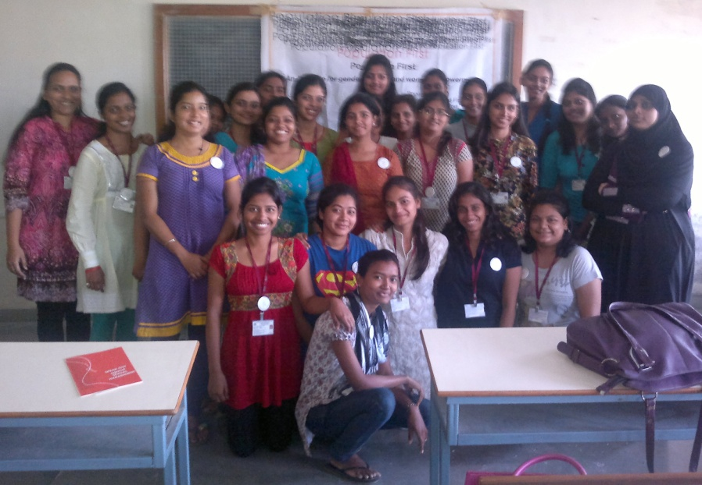
Members of Changemakers Club
KavitaShukla,who was one of the students conducting the survey reflects, “It was a huge learning experience for us. The women took a long time to open up and were hesitant to part with information. I was astonished to discover that one among five women had been beaten up and had borne it silently. We gave them some information that they could use like we told them about the phone number 103 which they could call if they were being harassed in any way or about NGOs like Population First which they could contact. More importantly, we explained to them that tolerating injustice was as wrong as inflicting injustice. As for me, this survey has made me even more aware of gender issues. I also asked myself what I would do if I were in their situation and realized I could never take violence silently.Mujhechuprehnanahinaata(I cannot keep quiet) and I know I mustn’t remain quiet in the face of injustice.” The exercise of conducting the survey turned out to be a memorable endeavor for the students and raised their gender awareness significantly.
Street plays and film-making competitions
Inter-collegiate competitions have always been popular among the student fraternity and are a proven way of whipping up opinions and emotions on any issue. As such, the Laadli team, headed by Nita Khajuria, organized quite a few inter-collegiate competitionsfor students, in 2013. These included competitions in essay-writing (‘portrayal of women in Hindi cinema and television’), street-plays (‘youth as agents of change’), and blog-writing (‘Nirbhaya and after’). “Events like competitions have always been more effective than plain lectures in stirring up students’ interest in issues and we saw that in the case of the sixteen teams that put up street-plays,” reports Nita. “The animated discussions on the subject among the students that precede the conception of such plays ensure that the students get thoroughly sensitized on gender, enough to sensitize others.”
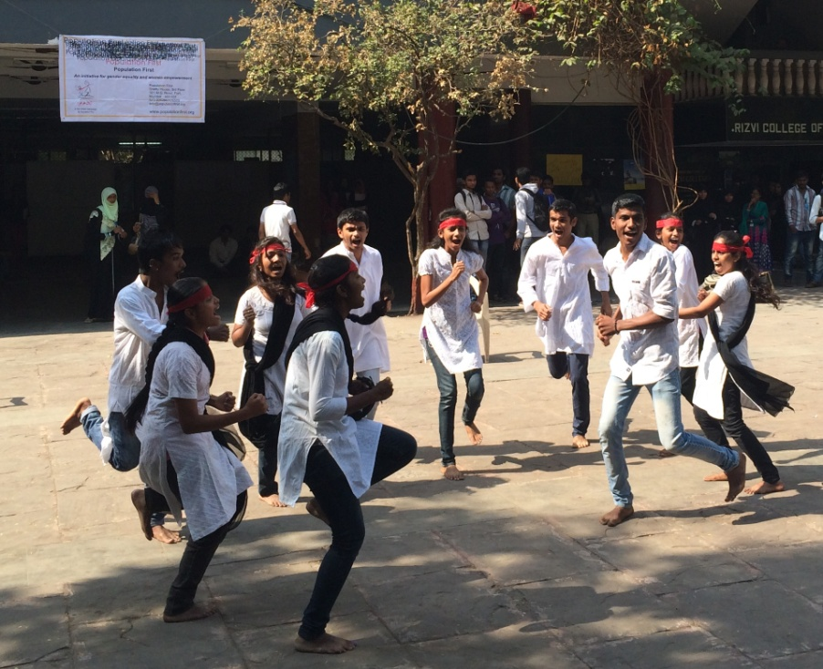
Street Play performance at Rizvi College
Nita’s observation is corroborated by RohiniBhosale, TYBCom student of Vile Parle LJNJ MahilaVidyalaya, who curated the first prize-winning street play. Rohini would always be bothered by the fact that girls had to face molestation of different degrees not just on the roads, but even in their classes at the hands of lecherous sirs and in their homes at the hands of some maamas or chachas, and had to swallow these indignities silently. She decided to challenge this situation.Along with five friends she scripted a play showing the victims of eve-teasing as rising in protest against their molesters. In the one-minute play, a young girl confides in her mother about her uncle touching her in the wrong places, and the mother gives a dressing down to the uncle; another young girl beats up the taporiwho harasses her and still another grabs the wrist of her depraved sir and rebukes him, asserting, ‘Bahut ho gaya’ (Enough is enough). “Doing this play has empowered me,” says Rohini. “I no longer feel helpless in the face of eve-teasing. I know now that we girls have to protect ourselves and we can do so. I learnt about different strategies of protest and self-protection from the other plays in the competition.”

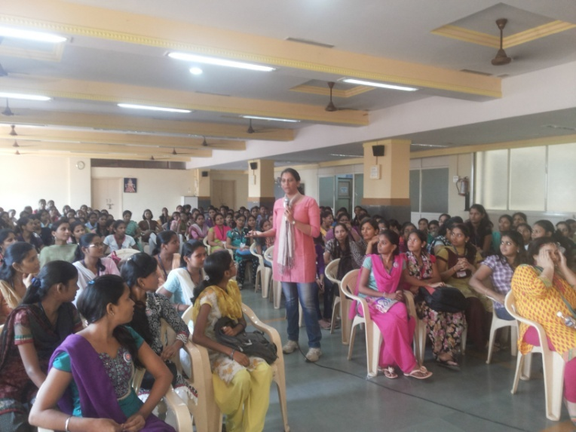
Ms. Gauri Patwardhan of Population First conducting a Workshop with students at L.J.N.J. College
Apart from workshops and competitions, the Laadli team also tapped other traditional and modern media to conveytheir messages to students. Like screening one-minute movies on gender issues for young college students andfacilitating debates on the same. To encourage students to use the powerful medium of films to raise gender awareness, an all-India one minute film competition on the subject of ‘Young mothers – India’s hidden tragedy’ was organized by the Laadli team. “We got only 25 entries, but the quality of the films was good. It’s a good beginning,” remarks Nita. Cash awards were given to the first three award-winning entries.
The regular sight of young girls in the local trains carrying babies and selling things, moved Nishajyoti Sharma of Tata Institute of Social Work to conceive her film on “Young mothers – India’s hidden tragedy.” Says Nishajyoti, who won the first prize “These young mothers in the trains played on my conscience and my two friends Vaseem Chaudhary and Jatin Virdi, with whom I made the film, decided to do something about child marriage. We felt (and got convinced after we researched further) that young maternal age is directly related to girls being married off at an early age. This is a matter of grave concern in India (and many underdeveloped nations) even today. And we firmly believe, young girls can be saved from this plight of becoming young mothers, which is dangerous for them, only if child marriage is stopped. “
Nishajyoti concludes, “This film, also a first for us, has certainly made a difference to our lives. We try and show it to as many people as we can to raise awareness on this issue and are glad that in our own small way, we have contributed to this social concern.”

Puppet shows
Students, once sensitized on gender issues, can become powerful bearers of the same message and take it effectively to the masses. Populaton First decided to galvanise this force in 2013, using the stage provided by the annual Ganpati puja celebrations. “We all know that people coming to the Ganeshapandals are in the right frame of mind to watch some performance, be it a song, skit or a puppet show,” elucidatesGauriPatwardhan of Population First. “In fact, people expect the Ganesh Mandals to organize some kind of performances. We decided to work on these expectations to further the concept of gender equality. We approached four students from NirmalaNiketan College of Social Work, who regularly associate with us for their field experience, explained the issue of sex selection to these students, and asked them to prepare a performance on the same. They understood the concept and came up with the idea of a puppet show to convey the message to people. We helped them and guided them in every possible way, but made sure that the students did everything right from writing the skit to sorting out various problems they faced as they portrayed many characters with only four puppet artists. It was a great experience for the students as they got to perform their show in front of hundreds of devotees. And the show was received very well by viewers.”
Four shows were organised at different Ganesh pandals in Mumbai – Abhyuday Nagar in Kalachowki, Khetwadi in Girgaon, Shahunagar in Mahim, and in
Girgaoncha Raja, Girgaon – between September 12th and 15th; the message reached more than 600 people. The concept and activities carried out under the Laadli campaign were explained before each performance and communication material on Laadliwas distributed after the show.

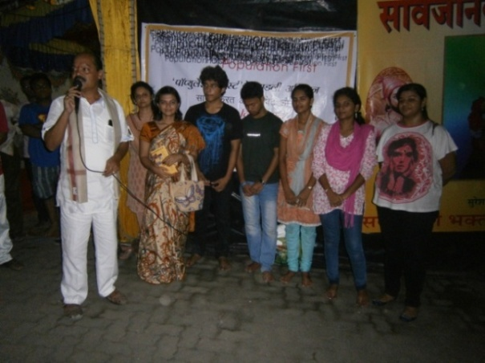
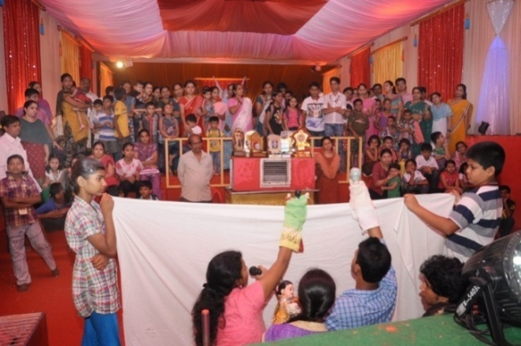
“This proved to be an important experience for the students as it gave them exposure to the ground realities of social work and also the confidence that they indeed could engineer social changes,” notes Gauri. Her remark is bolstered by Kiran who was one of the foursome behind the puppet shows. “Women today are facing multiple problems, we focused on a few like child marriages and eve-teasing through the puppet shows,” says Kiran. “This event gave us new ideas about how we could communicate with people and sensitized us even more keenly on gender issues. The response to our shows was encouraging. In Cotton Green, a woman requested us to repeat these shows during the Navratri celebrations, but we could not as we had our exams then.”
A worthy precedent had been set for sure!

Sensitizing teachers
For students to be sensitive to gender, it’s imperative that their teachers must be so. Population First has been tailoring workshops for teaching and even the non-teaching staff of colleges in the last few years. MariyahGour-Ghori,Head of the Department of Sociology at Rizvi College, who attended the workshop on gender held in Rizvi College by Dr.Sharadaon 4th September 2013, for both teaching and non-teaching staff commends the project. “It was attended by about 90 members of our staff and it really helped open up minds. One of our male faculty member is extremely patriarchal in his behaviour. His attitude has changed remarkably since the workshop, and life has become smoother for my colleagues and me.” However, Gour points out that many of the concepts like sending daughters for higher studies did not go down well with the non-teaching staff, and they grew belligerent. Indeed the workshop revealed the need to conduct such workshops solely for the non-teaching staff.

Facilitation Gender Debates in Classroom
To facilitateteachers to address gender issues in the classroom, Population First further had come up with the idea of developing a facilitation module. “In the course of interactions, students would sometimes remark that gender is a boring subject,” explains Dr Sharada. “I realized gender needed to be taught in an interesting manner. We had developed a CD on gender issues in 2007, but to use it effectively, teachers needed to have high facilitation skills. So we joined hands with Research Centre for Women’s Studies (RCWS) of SNDT Women’s University of SNDT University to develop thisfacilitation module for teachers titled “Facilitating Gender Debates in the Classroom.”

This powerful facilitator comprises four modules. Each of the four modules concentrates on one aspect of the gender story and has been prepared by a subject expert. Module 1 is about ‘Understanding gender and patriarchy’, by Gita Chadha; Module 2. ‘Feminist research methodology and techniques as pedagogic tools’ by VeenaPoonacha; Module 3. ‘Culture, pop culture and gender’ by A.L.Sharda and Nita Shirali; and Module 4: ‘Violence against women’ by Vibhuti Patel. Each of this module consists of comprehensive essays as well as brainstorming exercises based on theatrical techniques, to make students aware of issues like gender violence, patriarchy, feminist ideology, and to get them thinking and talking on these subjects.

Like Module 1’s section on Nature or Nurture? Biology or Culture? offers this suggestion to teachers:

(Activity 5) Ask the group members to list some of the expected behaviour of young girls in their communities. Lead a discussion on how these expectations are ensured or communicated to the girls? Through whom?By what means? Also lead the discussion into what happens if these behaviour expectations are violated? What happens if they are followed? Through the discussion, draw out the idea of how men and women are socialized into becoming masculine and feminine respectively.
Projects and assignments are also suggested. Like Module 2 recommends the following assignment to sensitize students to gender issues through oral histories:

Undertake three-generational studies on education or child rearing practices or women’s work. The project could be assigned as an individual or group exercise.
Assistant Professor of History in SNDT collegeNamrataGannerisees the module as an useful tool that will come handy to her as she teaches feminist theory to her students. She opines that the module which provides cogent exercises like asking students to write gender-sensitive matrimonial ads instead of the conventional ads for “fair, beautiful brides,” and other effective conversation openers, is necessary in view of the generally low gender consciousness among students today. “Our students are not well-read, they do not even read the papers,” regrets Namrata. “So they have not grown into accepting gender-sensitive language. Like over the last thirty-forty years, women are not addressed as Miss or Mrs. Nobody taught us that. But today’s generation is not even aware of that level of political correctness. So such things have to be taught in the classrooms and I use material from the facilitation modules to educate my students.” Clearly this has been a step in the right direction.

Gender workshops with media
It was an early realisation of Population First that if they aimed to modify people’s gender perceptions, they had to rope in the media which reflected and largely shaped public opinions and sentiments on all issues including gender. Thus media has been a focus area for Laadli from the beginning. Over the years, theLaadliteam hasdesigned and held several gender media workshops, to help journalists look into their own perceptions of gender and correct these. For finally what a media person projects is bound to be deeply influenced by his/her own prejudices and beliefs. And a lot needs to be done here considering that gender issues do not get adequate coverage in the media and women often go under-represented in news coverage in India. Indeed one rarely finds issues addressed from a gender perspective in newspapers and magazines.

“We are all a product of patriarchal mind-sets,” statesDr Sharada. “Our job at Population First is to hold the mirror to journalists and otherson how we reinforce and perpetuate gender stereotypes, particularly those stereotypes which harm society in the long run. We try to focus on modifying the core values that drive people and we hope to bring all people to commit strongly to the idea of a just, inclusive, violence-free society. We have been working very closely with the media, since this constitutes a highly potent platform that can be effectively utilized to alter the mindsets of the masses, as well as the classes. We give Laadli Fellowships and awards in various media streams, besides conducting workshops for upcoming journalists.”

The media workshops are orchestrated by Laadli in different cities in India, deploying myriad techniques. November 2013 saw two such workshops organised in North India.

Gender and media workshop in Lucknow

This two-day residential training programme for media persons from the print and electronic media from Uttar Pradesh and Uttarakhand, was organised in Lucknow on 7-8th November in Hotel Gomti. The programme was attended by 22 persons from varied print and electronic media viz Dainik Jagran, Shadhna News, Aaj Tak, Jan Sandesh Times, Intext, Live India Channel, Hindustan, Portal:Khabar Par Nazar, Times of India, Sahara Samay Channel, Sonebhadra, Rashtriya Sahara, Jan Satta, ETV, Gaon Connection, Amar Ujala, India TV, Tarun Mitra and IPN Agency.

Interactive in nature, the workshop aimed to provide media persons with an opportunity to understand more about gender issues. It aimed to allow them to explore the gender underpinnings of issues related to education, health, violence, etc. and help them develop the necessary conceptual framework and tools needed to analyse news and events from a gender perspective.

The workshop was formally inaugurated by Subhashini Ali, former Member of Parliament (CPI), activist and columnist. She set the tone for the workshop as she narrated the history of patriarchy and explained how greed for property and inheritance led to the desire for sons. The falling sex ratio is the result of the same patriarchal thinking, and it has also engendered insensitivity towards women in men. “The media can make a difference by looking at each story through a gender lens,” Subhashini maintained. She also informed the participants about how Sweden has pioneered the practice of assigning gender rating to films.

The workshop saw various distinguished speakers, emphasising on different sides of the subject. SunitaAron, the Senior Resident Editor of Hindustan Times, stressed upon the need to give attention to vocabulary when writing women-related stories. UNFPA representative AnujaGulati gave a presentation on gender, clarifying the difference between sex (biological and cannot be changed) and gender (how a person is seen by society and can be changed). She elaborated on how gender-based division of labour started from the stone age, how genders are formed and get impacted and reinforced by several actions; how in patriarchy men control everything from productivity and sexuality to economic resources and property; and how even our education system is engendering a gender bias. She concluded by pointing out that journalists needed to analyse events through a gender perspective and focus on the root cause of violence against women.

In her second presentation, Anujadetailed various treaties which acknowledged violence against women (VAW) as a human rights issue, and touched upon various other aspects of VAW like how it has been identified that VAW is not a result of lust but the consequence of a quest and show of power. Also, the statistics of VAW in UP show it has assumed epidemic proportions and this is impacting women’s health in that state. She pointed out different areas for such reporting in the current scenario and offered guidelines to journalists on the same. These are: “Follow gender-sensitive protocol especially while documenting injuries on women; use sensitive language that willnot embarrass the women involved; maintain confidentiality; always cross-check the story; do not harass the survivor or her family; narrate the story from the survivor’s perspective; and recognise sexual violence as a tool that is used to control or dominate women.”

On the second day, Anujadwelt on the evil of sex selection and how the sex ratio in India would dip to 900 girls/1000 boys in 2021 if the business of sex selection continued. As it is, 5 lakh girls are reported to go missing in India every year. She highlighted that the problem of sex selection which is rampant in urban areas and among the upper class is now spreading fast to rural and tribal areas. The implications of a declining sex ratio are polygamy, child marriage, trafficking, and increasing physical, mental and emotional abuse of women. She also explained the two Acts, Pre Conception Prenatal Diagnostic Techniques(PCPNDT) and Medical Termination of Pregnancy (MTP) and detailed how they overlapped sometimes and stepped on a woman’s right to abortion. Thorough knowledge of the Acts and sensitization of legal authorities and journalists is necessary.

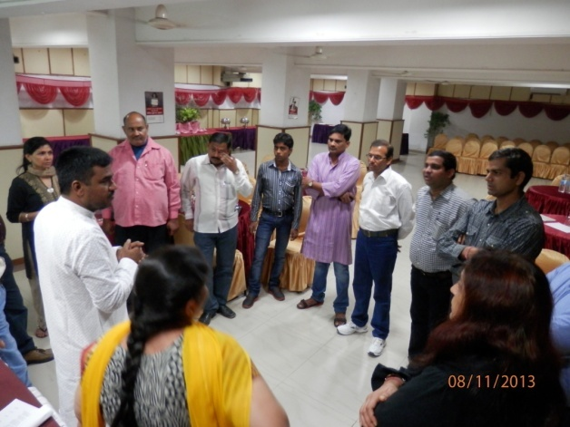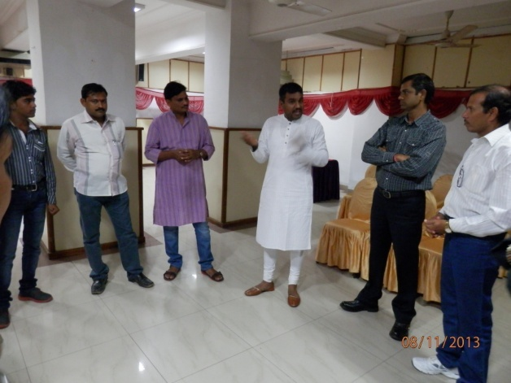
Participants at the Gender Media Workshop

Dr.Sangeeta Sharma Secretary Human Unity Movement (HUM)stressed on the need for a healthy work relationship between the police, media and social workers to check increasing crime against women. This joint venture can also ensure that ultrasound centres are not misused for sex selection. “Media is a trendsetter and therefore has more responsibility and needs to be extremely careful in reporting.”

Among others, Dr Shilpa Nair,Project Director FHI 360,h exposed the link between gender and health, pointing out how generally by the age of five, a girl starts facing discrimination in all fields- nutrition, immunization, education, physical activities, life skills, and the rest. The result of these disparities is anemia, bad health, weak immune system, stunted growth, early marriage, multiple pregnancies, high maternal mortality, unsafe abortions and more. And thus though nature has made the female sex stronger than the male sex by birth, she ends up as the weaker sex and depends on her father, brother or husband to lend her an identity.

“Media can change this situation, build women’s self-esteem andmould the mindsets of men by giving more positive stories, spreading information about government schemes in rural areas so that there is a demand for the same, and by focusing on champions of change, instead of focusing on gender conflict,”stressedShilpa.

GauriPatwardhan of Population First startedher presentation with a short film, a collage of various advertisements, and explained how they createdregressive stereotypes and influenced people’s mindsets. She analyzed various types and forms of media and their styles of reporting. The focus of her presentation was the reluctance of the media to break gender stereotypes, the skewed depiction of sex and relationships in various media, and the images of boy and girls that are projected by the media. “These images are emulated by boys and girls in real life, and these often lead to health (mental and physical) problems, loss of self-esteem, and life-style related disorders in them,” she said. She closed her presentation by urging the media to think how they could chip in to correct the situation, and demystify harmful stereotypes.

DIG LucknowNavneitSekeraenlightened the gathering about the 1090 Women Powerline. “It is not named Helpline as the aim is to empower women and not weaken them further,” he clarified. He also talked about the roles of society and families in instilling the right values in their sons, to bring down the rate of crimes against women.

The workshop left its young journalist participants all charged and committed to change. A few of their voiced resolutions and realizations are as follows:
- We will be extra careful about our language while reporting on women’s issues.
- Earlier we portrayed women as weak and as victims and thought it was correct to portray them in that way. Henceforth we shall project them as strong and powerful and not refer to them as victims.
- Follow-up of stories is a must and be it gender reporting or reporting on any other issue, we will follow a story till it reaches its logical end.
- Knowingly or unknowingly we are also to be blamed for treating women the way they are being treated in society today. First thing we will do now is tochange our own behavior and then we will motivate others to do the same.
- Gender will find a place in all of our news reporting.
- Our understanding about ‘what is gender?’ has got enhanced. We will explore the hidden gender aspect of stories now.
- We have got new ideas and new perspectives to do gender-related stories.

Gender media workshop in Chandigarh

The workshop at Chandigarh on 11th and 12th November was an equally high-spirited and effective event, involving 14 participants from Dainik Bhaskar, Amar Ujala, Aaj Samaj,Dainik Savera Times, Kashmir Times, Kashmir Images,and freelancers from newpapers, blogs and web.

Deepak Dhiman, Resident Editor, DainikBhaskarbegan his keynote address on gender and media by stating that a journalist is one who learns, unlearns and relearns every day. He asserted that gender-related news are important to cover as they concern half the population.

Dr.SnehaKhandekar, Savitribai Phule Gender Resource Centre (SPGRC) Mumbai,the first speaker of the workshop started her sessionasking participants to list out adjectives for a man and a woman. As her session progressed, she clarified to participantsthat all the adjectives that they thought were gender-specific were in fact gender-neutral and could be applied to both men and women. Once the difference between the terms “Sex” and “Gender” was grasped by the participants, she explained the patriarchal system, how it affected the mentality and attitude of men as well as women, and how women derived their power from men in the family.

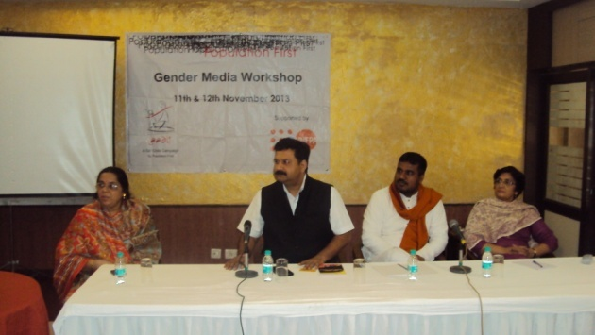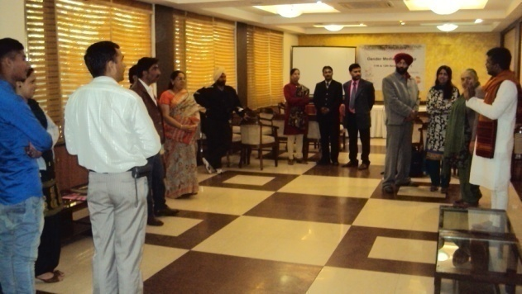
Participants at the Gender Media Workshop

She also initiated an animated panel discussion on the subject of sex selection, the reasons for its widespread abuse in India, and ways in which journalists could stem this abuse. Monica Sharma, a journalist with The Hindustan Times, insisted that no woman would ever opt for sex selection on her own. “If a woman goes for a sex determination test, she will be doing so either under direct pressure from her in-laws or because of indirect pressure exerted by the patriarchal system prevalent around her. Eradication of sex selection depends largely on a change in the male mentality.” Hema Sharma, a journalist with Punjab Kesari, dwelt on the deep-set preference for sons. “The first blessing every woman in India receives after marriage is “PutravatiBhav,” meaningbecome the mother of a son.If a woman has a son, she gets lot more respect in the family than she does if she has a daughter. This mindsetis at the root of the practice of sex selection, and it needs to be changed.”

The sex ratio in India really got skewed post 1980 when ultrasound technology came to India as people started abusing the technology right away. This important fact was underlined by Dr. Renu Malik, who represented the Haryana Government at the workshop. She also cautioned people to not confuse sex selection with safe abortion, and the two Acts PCPNDT and MTP associated with them. “These are two different things. The law gives every woman the right to decide whether to continue or terminate her pregnancy. Her signature is what matters for an abortion. The signature of the husband/male partner has no value.”Dr.Malik’s point was reinforced the next day by Medha Gandhi ofIPAS India, who underlined safe abortionas a right of every woman and the need for her to have access to it. The harsh reality today was that every two hours, a woman died of abortion-related deaths in India.The speeches with their accent on the gravity of the issue, subtly pressured journalists to write more about gender issues in a sensitive manner.

GauriPatwardhan, Population First regretted that the media – whether it be print, electronic as also the social media portrayed women today in either a stereotypical or gender-unjust manner. “I pray that each one of you attending this workshop, will commit to at least one thing to change this situation.”

And in fact, in the last session conducted by ManjulBharadwajof the Experimental Theatre, the participants vocalized several commitments like “We will fight for gender equality first in our homes;” “We’ll widely share the content received in this workshop,” and “Our way of looking at women has changed now. We will now look upon women with a lot more respect.” The comments stamped the success of the workshop.

Editors’ meet in Hyderabad

Sometimes it happens that a journalist may write or work on a relevant gender-based story only to come up against an editor’s opposition, for they may not share the same convictions andpriorities. Editors, be it of print or electronic media, play an important role in determining both the nature of the content that is transmitted to the public and the tone of the relay. As such, Population First in collaboration with Bhumika, Hyderabad organized and conducted adialogue and reflection session on the 14th of November 2013 with senior editors from the print and electronic media at hotel Taj Deccan, Hyderabad. The workshop was titled “Nirbhaya and After: Media Response to Gender-Based Violence and the Way Forward.” About 25-30 editors, creative directors and media persons from various platforms, including NTV, Andhra Jyothi, The Week, 10 TV, ABN Andhra Jyothi, Saakshi, Zee Telugu, The Hans India, Express, Indian Express, Vanitha, Eenadu and Deccan Chronicle, among others, came together on a common platform. The program was anchored by Hyderabad-based journalist Roopavani.

Roopavaniinitiated the program by setting out the context for the workshop – the increasing atrocities being committed against women and girls. The barely one-year-old Nirbhaya incident that occurred in the national capital in December 2012 (a young woman gang-raped and brutally battered in a bus and finally succumbing to her injuries) had shaken India. It had also created a sense of insecurity and palpable fear among women. The workshop thrashed out the reasons for this increasing violence against women and how the media contributed to it through factors like repeat telecasts of gruesome acts perpetrated on women and usage of inappropriate language.

The erudite and experienced speakers highlighted different aspects of the malaise.Population First Director,Dr. Sharadapointed out that while India’s progress on the economic front was evident for everyone to see with the country rising up several notches in its quest to attain superpower status, the country has been on a downward spiral going by the gender-related development index (GDI). This has been visibly manifest in India’s declining sex ratio and the plight of its women and girls. The media has had a significant role to play in this state of affairs, she rued. “For instance, acts of crime against women are routinely projected by the media in all their gory details, playing on the two emotions of anger and grief (tears). This sends highly erroneous messages to viewers, who are left aghast at the brutality on display. This has been highlighted prominently in the Nirbhaya case of December 2012, after which several women have purportedly been thankful for not bearing girl-children. While the onus of providing safe and secure messages for women lies with the media, they have been found to be doing quite the opposite. The media has to first define the very purpose of its writing, whether it’s to promote a cause, engineer social changes or to just gain TRPs to enhance its business. For finally content decides the style of presentation.”

Kalpana Sharma, columnist, senior journalist and former Deputy Editor of The Hindu, reinforced Dr.Sharada’s point. “Violence against women has become front page news today, more so after the Nirbhaya incident,” stated Kalpana. “Since New Delhi was the national capital, the media was prompt in followingup on the Nirbhayaincident; but by and large, conviction rates in rape cases have been inordinately low due to lack of adequate follow-ups. Isn’t following-up our duty as journalists? Again, while a woman survivor tries to deal with her trauma in the best possible manner, the media plays spoilsport by harping on the issue with least consideration for the distressed party. The first information report (FIR), which is not a public document unless produced in a court of law, is often acquired by the media using underhand means, which further aggravates the trauma for the survivor. Dramatization of issues through graphic illustrations are rife; this createsa sense of fear, restricting women and girls from venturing out at unacceptable hours.”

Another aspect that she touched upon was discrimination in news reporting. “Even trivial incidents in the life of a well-known woman celebrity become headline news for the media, whereas a minor slum girl being brutally rapedis accorded no importance at all.” Sharma concluded that while gender sensitivity is lacking among the general populace, the media needs to adopt a professional attitude. Photographers and cameramen have to be made aware of the significance of shooting with sensitivity, and all of these are highly doable factors.

Sharma’s views on selective reporting by channels and lack of follow-ups by the media were fully endorsed by Dr. TripurnaVenkataratnam, Chairperson of Mahila Commission, AndhraPradesh. She also pointed out, “In numerous instances, the media focuses primarily on perpetrators of crimes, such as rapists, elevating them to the status of heroes.” K. Satyavati, Executive Director, Bhumikarelated how a young girl had asked her as to why the feeling of fear was highlighted by the media, instead of offering solutions on how to overcome it. “The human angle is missing in media coverage and women are portrayed in a negative manner,” regretted Satyavati. “For instance, in television soaps, women are depicted as chief adversaries of other women and mothers-in-law are pitted against daughters-in-law. This has the effect of disharmonizing the environment. ”

All agreed that television channels played an important factor in creating negative mindsets. C. Vanaja, a senior journalist, revealed, “While I was employed with Vanita TV, I’d observe the highly aggressive format in which any breaking news was presented by the channel. Rapes were sensationalized with graphic details added for good measure. We had to remain silent, there was no other way out.” Mr. Prasad Murthy, Programming Head, ABN Andhra Jyothi, corroborated her experience recalling, “During my initial days as a media person, seniors were forever badgering us juniors to find out means that would result in enhancing TRPs. The objectives and principles of current day’s media have been eroded by the single-minded concern forgarnering profits.”

While castigating the media, particularlyTelugu channels for being insensitive to gender issues, writer and columnist Mrinaliniobserved, “Gender sensitization is not a diploma and forms a very crucial part of an individual’s upbringing.” This remark was substantiated by the experience of Hyderabad-based journalist Mohan Divakar, attending the workshop. “As a child, I would see my uncle preparing morning coffee and breakfast and helping my aunt in her domestic work, including cooking,” narrated Divakar. “My mother taught me the basics of cooking early in my life. Even today, I love getting into kitchen and cooking. For me cooking is a kind of meditation.” Also, the experience of growing up with three sisters gender-sensitizedhim. “Because of my sisters, I understood things like the agony of victims of eve-teasing. Besides, I was introduced as early as when I was in the sixth standard, to the world of Sharthchandra's literature. The women in SharathBabu's novels greatly influenced me. So much so that I took a vow in my childhood that I would never indulge in eve-teasing nor encourage such acts.”Diwakar’s statements underlined the greatverity that gender sensitization has to begin at home. The values that we inherit from our parents, grandparents, and others in our environment stay with us all our lives.

The esteemed gathering proposed and discussed various ways of awakening gender sensitivity in the media and redressing thecurrent situation. Almost everyone concurred on the need to train journalists on gender issues and encourage a trend of following-up on gender-based stories. Dr.Sharada maintained, “It’s imperative that journalists be educated in the proper methodology of writing gender-oriented stories.”Kalpana Sharma confirmed, “The need for proper phraseology cannot be overemphasized. Journalists need ongoing training in storytelling and proper briefing, which is lacking. The outcome of any incident has to be contemplated with utmost care by senior editors.”

Shailesh Reddy, Chief, ABN Andhra Jyothi ascribed the current crisis of ethics in the media to the severe dearth of trained journalists and their recruitment process, which he claimed was “intrinsically wrong – people are hired on the basis of their writing skills and without any thought to their perspective. Recruitments must be done with more care,” he stressed. “Also, including a gender issues editor would go a long way in enhancing the quality of gender-based reporting.”

Nagesh Kumar, Resident Editor, The Hindudrew the attention of the gathering to a grossly underused facility provided by television. “Various television channels of today that telecast news and various programs have a scrolling message, which states that in the event of any disagreement with the channel’s content, the audience has the right to voice its concerns. The audience should be more proactive and in cases where the content of channels appears to be improper, bring the same to the notice of the concerned channel,” he opined. Buttressing his point, Vasantha Lakshmi, Assistant Editor, Andhra Jyothi,pointed out that while a major proportion of the television serials are viewed by women, they never come forward to remark on the content of the same. This needs to change.Satish Kumar of ETV2 compared this to the reluctance seen among women in forwarding RTI petitions. “MahilaSanghas must come forward to enhance the participation of women,”he averred.

J.S. Ram Mohan, Assistant Editor, TV9, remarked that some change had definitely been observedin the attitude of the media post Nirbhaya, but more needed to be done. “The media has to act as a “change agent” and not as a money-making operation. A major reason for crime flourishing in the present day is the recurring telecast of stories related to a range of misdemeanors, such as the Nirbhaya incident. This further warps the mentality of individuals vulnerable to criminal intents. While journalism of yore was associated with imparting education, today this seems to have been forgotten, which has to be changed along with the promulgation of redressal mechanisms within the media.”

For sure, this editors’ meet was bound to create ripples and have a snowballing effect on the participating journalists, and the channels and the publications
represented, and through them on society.

Laadli media and Advertising Awards for Gender Sensitivity
Perhaps the strongest incentive to do good work is appreciation of one’s efforts. Thus, early in the Laadli campaign, in 2007, the Laadli media awards were conceived. The awards rested on the belief that “the media can change the way we look at gender equations by projecting new images, new aspirations, and a new worldview which is more gender-just and inclusive even within the constraints of a globalized market-driven economic system,” explains Dr. Sharada. In her words, “the awards were launched with the support of UNFPA, to identify, acknowledge, and facilitate media and advertising professionals who are providing a critical insight into gender prejudices as well as those who are reflecting the changing gender equations. Laadli rewards all those journalists promoting public awareness and understanding of gender issues, influencing policy or legislative change regarding women’s rights, showing courage, originality and creativity in depicting/reporting gender issues, and finally presenting events/issues through a gender lens.”
And the beauty of these Laadliawards is that they are not confined to the metros or to the English language, but reach into remote parts of the country, identifying good work that is being done in far-flung areas like the North-East and J&K, and that needs to be held forth as examples for others. Till date, Laadli has given 271 awards in 13 languages. The Awards encompass a year-long effort, involving journalists and editors who are requested to send entries/nominations for the awards as well as a number of opinion leaders who support the awards as jury members, sponsors, partners, performers, and guests.
What is heartening to note is that both the number of entries and their quality has improved significantly over the years. Revathi Asokan of Population First, who engages actively in this area, reveals, “When we began in 2007, we got about 100 entries. This year, the entries numbered 1,700, which is a mark of the growing popularity of the awards. Also, earlier the entries did not reflect proper understanding of gender – the entries would relate to only women as if gender compassed only women and not men. But now they are more in line with the concept. Earlier we would receive entries about women working in beauty parlours and the like, now they are pivoted on more serious issues.”
For instance, the national award-winning entries of 2011-12 Awards( while the regional Award events were held in 2012 the National LaadliMedia Award event was held in February 2013)included a feature on IBN – Lokmat, Maharashtra by PrajaktaDhulap, highlighting the innovative work of dedicated people and deployment of technology to effectively tackle the heinous crime of sex-selective abortion in Kolhapur district. A shining example of responsible journalism.
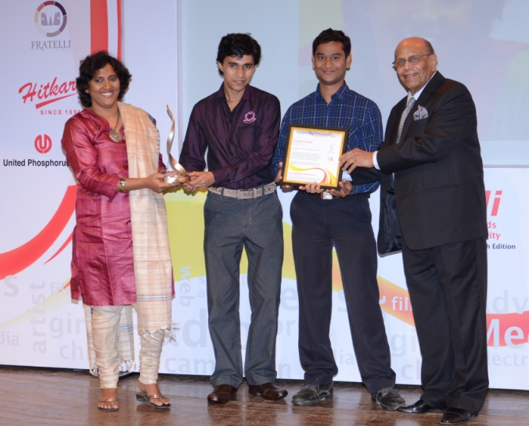
Ms. Prajakta Dhulap and her team receiving the National Laadli Media and Advertising Award for Gender Sensitivity from Mr. Bobby Sista (Exec. Trustee, Population First)
Another entry which grabbed a national award, was PriyankaDubey’s investigative story in Tehelka, Delhi on interstate trafficking networks, honor killing, and the selling of young girls in the Bachchada community, practices which are suggestive of the Middle Ages rather than modern times.

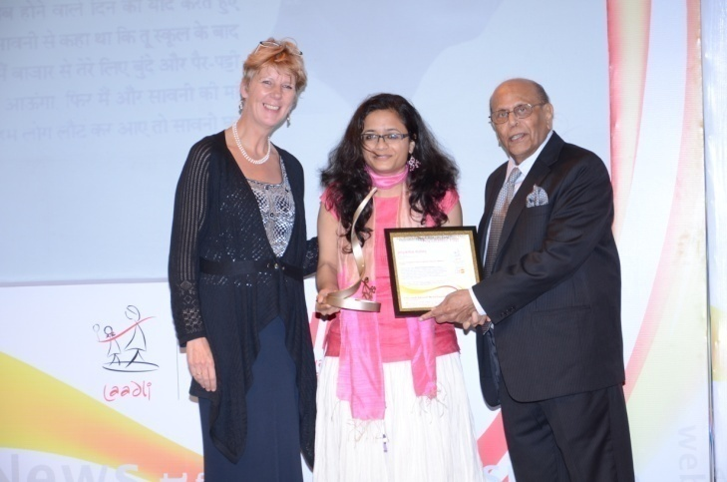
(L-R) Ms. Fredericka Meijer (Country Representative, UNFPA), National Award Winner Ms. Priyanka Dubey, Mr. Bobby Sista (Exec. Trustee, Population First)
The regional award-winning entries for the fifth edition of the Laadli Media Awards2012-13 are equally impressive, and drag into the public glare several important gender concerns mushrooming in different nooks and crannies of India. Like RatnadipChowdhury’s investigative story in Tehelka, Assam called ‘Manufactured Shame,’ which looks into the grave violation of media ethics and “on air moral policing” which act as a great hindrance to gender sensitivity in media. The story was fashioned in response to a video clip aired by a TV channel on July 9, 2013, showing a young woman being groped and molested in full public glare outside a pub in Guwahati and no one, not even the media present daring to intervene.
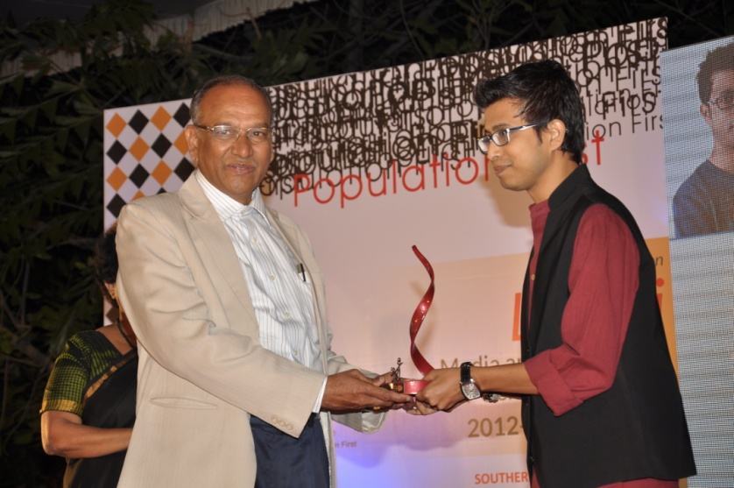
Mr. Chandra Kumar, Honourable High Court Judge(Andhra Pradesh) felicitating Mr. Ratnadup Choudhury- Eastern Region Award Winner
Another impressive award-winner is JanhaviSarate who has been consistently writing features in Marathi on women’s issues. One of her features, ‘JatPanchayatPaiseParatKarnar,’ focused on the important issue of JatPanchayat. She began by writing how the JatPanchayat was opposing a girl’s education after her marriage and how the girl was even ready to divorce her husband to pursue her education. The JatPanchayat also fined the girl’s family. But Janhavi’s consistent reporting on the issue had its impact, with the Panchayat actually withdrawing their opposition and accepting that girls have a right to education. The JatPanchayat promised never to take a contrary stand and even refunded the money extracted as fine from the girl’s parents.
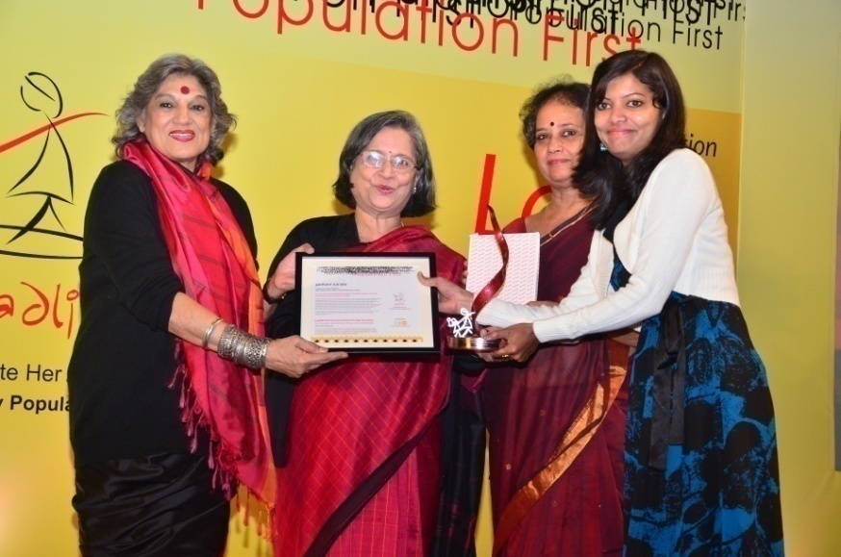
(L-R) Ms. Dolly Thakore, Ms. Sidhushree Khullar (Sec. Planning Commission), Dr. A.L. Sharada (Director, Population First) felicitating Ms. Janhavi Sarate - Western Region Award Winner
Comprehensibly, these Laadliawards act as huge motivators for journalists. Deepika Sharma of Nav Bharat Times, who won the Laadli award for the best article in Hindi in 2012-13, frankly acknowledges the positive change in people’s perception of her work and the resultant spike in her zeal to deliver. “I received the award for an article on lowering the legal age for consensual sex from 18 to 16. Before receiving this award also, I was doing stories based on gender issues. But now after this award, my work is being recognized, people in office listen seriously when I say something. Also, my own attitude to writing has changed. Earlier, I would think that our stories have a life of just one day and that would pull me down. But now I know that if it is a good story, it will have a longer impact, gain a life of its own. As a journalist, if one writes an article and no one responds to it, one tends to feel demotivated. This award has made me realize that a journalist has no business to feel demotivated.”
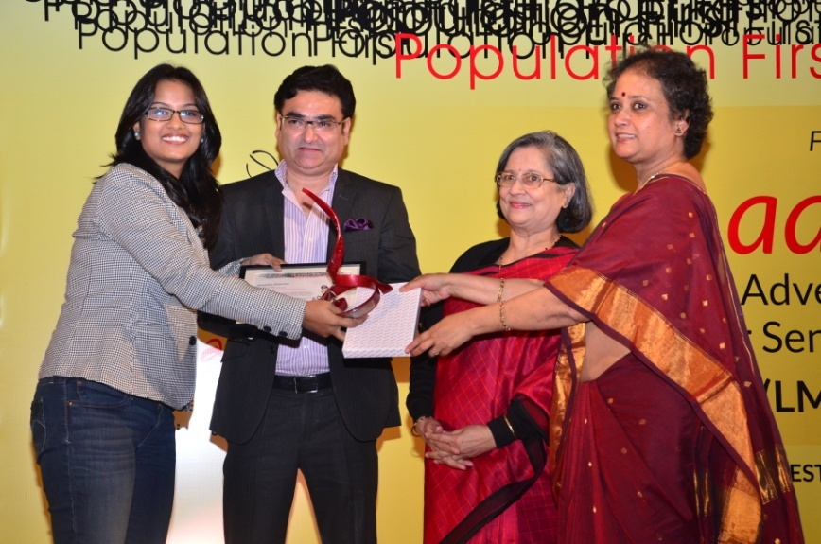
Ms. Deepika Sharma (Western Region) receiving award from Mr. Rajiv Mishra (CEO,Lok Sabha TV), Ms. Sidhushree Khullar (Sec. Planning Commission), Dr. A.L. Sharada (Director, Population First)
However, Deepika’s biggest draw from this award has been the radical shift in her parents’ attitude towards her chosen profession. Hailing from Bharatpur in Rajasthan, Deepika was troubled by her parents’ persistent disapproval of her work. Says Deepika, “When I first told them I wished to become a journalist, they were wary. They saw a journalist’s life as a dangerous one. They still have that view, but now after Laadli Award, they feel that I have made the right career choice and so I can now pursue my chosen profession with a lighter heart.”

The Eastern and Southern region Laadli Media and Advertising Awards event was held on 13th December 2013 at Hyderabad while the Northern and Western region Award event was held at Delhi on 20th December 2013.

Sense and Sensitivity – a benchmark of a book
With the passage of years, there is a growing awareness in the journalistic community of these awards and a silent drive to win the same. Each winning entry not only veers the spotlight on an important gender issue, but also inspires the conception and creation of other potential entries, other scathingly brilliant exposes of gender-related trends, events, and issues. In 2012, the Laadli teamcame round to the view that a bank of such entries would serve as a benchmark for the media and easily educate journalists on what constitutes good gender-sensitive writing. “It’d be a good documentation of our awards-related work in the last three years and also serve as a reference book for those who wish to write,” expands Dr.Sharada. And so Laadli brought out the book ‘Sense and Sensitivity’ in February 2013, showcasing select award-winning articles from the first three editions of the Awards..
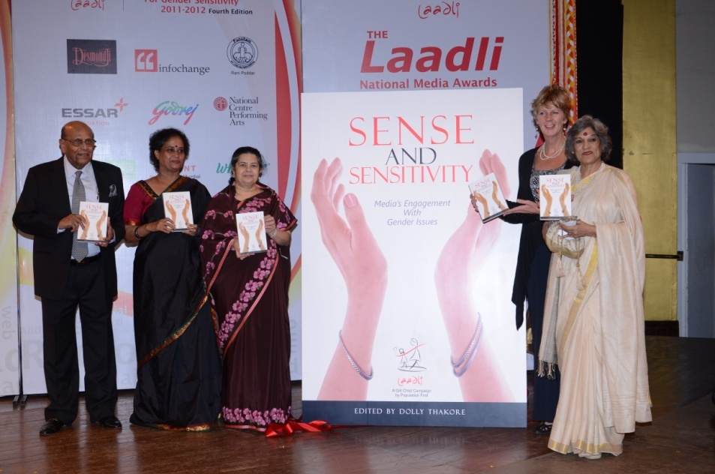
(L-R) Mr. Bobby Sista (Exec. Trustee, Population First), Dr. A.L. Sharada (Director, Population First), Ms. Rajashree Birla (Trustee, Population First), Ms. Fredericka Mijer (Country Representative, UNFPA), Ms. Dolly Thakore at the book launch of Sense and Sensitivity
The book is a compendium of news features, reports, editorials, columns, blogs etc. – from advertising, electronic, print, Web, and other media, and has been deftly edited by noted theatre personality Dolly Thakore.Each story in the book is a gripping, easy-to-read tale that points up one serious gender issue at least. The book is distributed among different stakeholders at seminars and media workshops by Population First. Along with the book ‘Missing half the story,’ which had been published in 2010 to put out a robust work on gender in the public domain, ‘Sense and Sensitivity’ continues to gender-sensitize people.

Laadli’s work with the advertising industry
If the influence of the print and electronic media in shaping our mind-sets is undeniable, then so is that of advertising. Indeed the effect of advertising is even more ubiquitous and what’s more, subconscious; advertisements subtly pass on messages that stay with us and govern our behaviour and choices almost without our knowing. Like a fairness cream ad is bound to play on the mind of a young dark-skinned girl and lead her to believe that she can never hope to be considered beautiful or desirable or successful as she is not fair-skinned. Ads on television which routinely project women as doing household work reinforce the gender stereotype that women are born to be essentially housekeepers and no more. Even more harmful to the cause of the girl-child and that undervalues her, is the way families are largely depicted in ads. A survey conducted by Population First revealed that any advertisement depicting a happy family usually featured either a boy and a girl or two boys, but never two girls; this reiterates the deep-rooted bias for sons that is at the root of the evil of sex selection.
Keeping in mind the subtleimpact of advertising on our lives, Population First has sought to gender-sensitize the ad industry from the beginning. This effort has taken various forms.

IAA seminar
In 2013, Population First took the initiative along with the International Advertising Association (IAA), to organise a one-day, high-level sensitization seminar called VOW, an acronym for violence on women.(16th February 2013).Condemning the widespread incidence ofviolence on women, the seminar resonated strongly with the advertising industry which had been shaken severely by the December 2012 Nirbhaya incident and was reflecting on its social role and responsibilities. The seminar saw many illustrious personalities from different fields like Kaushik Roy,Program Chair, IAA- IC; Anjali Monteiro, Prof and Dean TISS; AnujaGulati, State Officer UNFPA;Dr.Nandita Gandhi, co-director, Akshara; film directors ShyamBenegal and ZoyaAkhtar; SK Swamy, President, IAA – IC; actor MandiraBedi besides Dr.Sharada, dissecting various aspects of the gender and media connection and its repercussions on society.
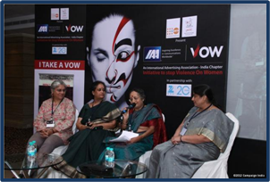
Early on in the seminar, AnujaGulati of UNFPA in her usual cogent manner threw some hard-hitting statistics about India at the advertising industry to knock it out of its slumber. The grim face of discrimination against the female sex and its outcomes emerged from the following facts and figures:
- 5.7 lakh girls go missing in India every year because of the practice of sex selection, which is more prevalent among the rich and educated people than among the poor. (An important implication of this fact – The possibility of a girl having sisters is rapidly diminishing).
- Under-five mortality rate for girls is 6.9 and for boys 6.0 per 1000 live births.
- Literacy rate is 65% for girls and 82% for boys.
- 29% of married young women initiate child-bearing by the age of 18. Repeated pregnancies and repeated eliminations (in the interest of a boy child) also impact women’s mental health beside physical and lead to high maternal mortality rates.
- 181 women die every day due to pregnancy-related causes.
- Violence is on the rise. Close to 35% of women aged 15-49 have experienced physical and sexual violence (NFHS 3, 2005-06).
- Two in five women have experienced domestic violence which impacts their bodies, minds and self-esteem.
- 9.6% of elderly women are currently living alone with no family support and of course are easy targets of violence.
These statistics themselves indicated the urgent need to address the issues of gender and violence on women. How did we best address it?
Anujawas ready with her solutions. “If women are to lead violence-free, dignified lives, then we have to empower them and this is possible by addressing discriminatory practices like sex selection and infanticide, providing education to women, involving them in gainful, if flexible employment, delaying marriages and pregnancies by providing better access to reproductive health services and contraception, and ensuring political participation of women. I believe media has huge power to bring about gender equality and stop violence on women,”she stressed.
A significant admission of gender-insensitivity of the ad world came from Kaushik Roy, Program Chair, IAA- IC. “I believe we are all guilty, we have been insensitive and contributed to the gender issue by passing on wrong messages” said Kaushik. “Like the constant fear that we drill into a woman’s psyche about being the perfect housewife. We keep admiring her for how she cooks, does everything, and still looks so beautiful, not a wrinkle on her face or a crease in her clothes. And subconsciously we pressure her to be all these things and stereotype her.” He stressed the need to sensitize content creators in the advertising industry to gender nuances and advocated innovative measures like the contest for the best ad on stopping sexual harassment, called eve-teasing, in public places.
KV Sridhar, NCD – Leo Burnett, a creative leader in the ad industry, radiated more optimism about the mutating ad world.His optimism stemmed from the simple but deep truth that finally we are all humans, the clients as much as the marketers and we all do good and bad things, knowingly and unknowingly, and we all have values. “In my 32 years in the ad industry I have not met a client who has said, let’s be racist or let’s blackmail women or let’s propagate lies,” observed Sridhar. “It’s finally up to us as creative people to decide on the story that we will write, and that story will come from our values, our experiences, and the images in our heads. As people in advertising, which has the power to change the way society behaves, we have to be careful. One can do an ad that will encourage and lead to deaths due to rash motorbike-driving and one can do an ad that will show these drivers how they can drive safely and survive. The choice is ours.”
And Sridhar believes the world in general and advertising too is moving in the right direction. “The world has become more transparent today; so there’s no alternative for people and companies but to be more honest. Secondly, everything has become a commodity today. And people do not buy commodities as much as brands and choose a brand because it reflects values that agree with them. Values are important and advertising, behaviour of business houses, and the way of marketing brands is definitely changing.” He referred to a commercial on HDFC’s unit-based savings plan, which shows a young woman giving a cheque to her dad to buy a big car, from her savings. “Through this ad, you can inspire people to feel how lovely it is to have a daughter and reverse the perception of women as liabilities,”revealed Sridhar. “How you sell an idea to a client is important. If you market it as an issue, it backfires. The ad proved to be so successful that HDFC actually launched a woman’s plan this year.“ Sridhar concluded, “You can be positive and influence people. It is ignorance that is the worst animal.”
Considering an average Indian spends 4.5 hours every day before the television, as stressed by Kaushik Roy, the seminar took a hard gaze at television soaps and their contribution to affirming gender stereotypes. Monica Tata regretted that though the history of daily soaps had started off two decades back with progressive serials like the path-breaking Shanti, replete with strong women characters, they had come down to regressive mother-in-law-daughter-in-law sagas in the last few years. MandiraBediwho had played the fiery journalist-protagonist in Shanti reflected on the 180 degree turnaround. “Though there are a few progressive serials, by and large ontelevisionyou see the protagonist to be an ideal daughter, daughter-in-law, sister, wife; her trials come from spineless husbands, plotting mothers-in-law and the like; her achievements are that she can keep peace in the house, bring up kids well, far, far from any board room; herself-esteem amounts to nothing; and she is admired for her sacrifices. And then there is an antithesis to this Sita – the modern ruthless woman, generally short-haired, much-despised, a master of seduction, and one who is constantly plotting revenge. Thus, you are loudly putting out the message that a woman who makes a career is selfish and bad. And a good woman is one who can bring up children well and run a house well.”
Ajay Bhalwanka, Head of Programming, Zee however begged to differ with Mandira’s perception and insisted that Zee has come out withmany a progressive serial like ‘Saatphera’ which tracked the travails of a dark-skinned girl from Benares, and that Zee is planning other serials of the same ilk.
If television has a hand in shaping people’s opinions, then cinema has an even bigger hand in it. Cinema has today emerged as the clear king of entertainment and become an ineluctable part of our surround; thus its role in determining attitudes towards women cannot be discounted. But can mainstream filmmakers afford to project women in new progressive shades and show the women’s point of view at all in the first place on the silver screen? Much-feted and noted film director ShyamBenegalof such path breaking movies as Ankuris skeptical about this possibility. “The basic idea while making mainstream films is to entertain people and to do that, you cannot alienate or antagonise them. So you end up reflecting everything that society tends to believe in – all its prejudices, attitudes and aspirations. If you want to change anything at all, the only way you can do so is by subverting it. Are you ready to do that? My film Bhumika (released in 1976) was a straight-forward case of subversion, based on a real-life story. The first two times it was released, it did not run; the third time it was released it ran for 25 weeks. The audiences that made it successful were entirely women. And I can’t give any other example like Bhumika, a film in which all the men fall short and are shown in a somewhat negative light. If am going to function in popular cinema, I cannot do this, I have to accept patriarchy, which is the basic nature of our society. The most successful women-centric film ever made,Mother India, too was within the paradigm of patriarchy and it beamed all the values that the patriarchal system says a woman should possess, and nothing else. Clearly that’s the situation even today. At the most, a filmmaker can attempt to show some changes here and there within the paradigm. Like in ZoyaAkhtar’s recent film Zindaginamilegidobara, she showed a woman chasing a boy and finally kissing him, which was not a reactive thing, she was acting on her own, which was a new thing, Otherwise you have women characters reacting to everybody else because in any case they are defined as someone’s daughter, wife, mother, sister…women-centric films are rarely made, for it’s difficult to get funds for the same, difficult to get male stars to act in these films.” Agreeing wholly with Benegal’s observations, director ZoyaAkhtardescribes her attempt as a director to at least retain the female gaze. “Most women directors in Hindi films adopt the male gaze to compete with male directors. A woman making a film thinks I must have a cabaret also as the men are doing it. So it’s extremely important as a woman to retain your gaze. I try to do it in my own way. Like in my film Zindagi…I could have shown Katrina walking out of the water in a bikini, the first time she meets Krithik and his friends, but I chose to show her in a strappy dress instead and have a very natural conversation.”
Clearly, there are no easy, beaten paths for the creative media person, who wishes to succeed and also make a difference. The success of the IAA seminar lay in the squall of thoughts that it managed to raise in its participants’ minds. Thoughts that are bound to reflect in actions someday.

Study of complaints against ads
It is not as if there are no rules or bodies to combat gender-insensitive advertisements. There are existing professional codes in the ad profession itself to regulate the projection of women in ads, the most prominent being the Code of Conduct formulated by the Advertising Standards Council of India (ASCI). ASCI enjoys the membership of 212 prominent ad agencies, 225 advertisers and 58 influential sectors across the country, which underline the importance of this body and its capacity to influence messaging. Anyone, from ASCI Board members to consumer organisations and the general public can complain suomoto against any offensive ad to the Consumer Complaints Council (CCI) of ASCI, a body that assesses such complaints and subsequently orders the withdrawal/modification of the ads. But how effective is CCI in tackling complaints, especially in the case of gender-offensive ads?
“We thought that a study of the action taken against offensive ads by ASCI was necessary,” reveals Dr.Sharada. “It would help in fine-tuning the regulations, especially chapters II and III of the Code which relate to the depiction of women in ads.” Thus, under the guidance of Population first and UNFPA, intern FerozaSanjana undertook a study last year – an analysis of the decision of ASCI on indecent representation of women in advertising. The study was conducted over six weeks during which 45 ads made from 2007 to 2012 were analysed. These ads were complained against for being either insensitive to women or having gender issues in them; the complaints emanated largely from the public.
It was found that the maximum number of complaints pertained to ads in which women were represented as sexual objects in contexts irrelevant to the product being advertised. The study noted that while some of these complaints were upheld, others in very similar settings were not upheld, without clear reasons. Again, ads which discriminated against men were not addressed always with the same measure of strictness as ads relating to women. Often the rationale provided by CCC for rejecting a complaint was imprecise and not adequately detailed.
But it is necessary for any code, law, etc. to have an extremely precise rationale; in the case of gender-sensitive advertising, the compliance code needs to be even more specific. As such, the study showed the scope and actively recommended further work on the guidelines enshrined in ASCI’s Code of Conduct.
As regards compliance, it was found that the compliance rate of total complaints upheld by CCC has increased from 75.4% in 2007-08 to 86.45 % in 2011-2012. For gender issues, the compliance level to complaints upheld by CCC is 100%. However, the number of complaints upheld is very low to begin with.
The study also revealed that the number of complaints against ads on grounds of gender has increased, which is a good sign of increasing gender awareness among the public. However, the number of offending ads too has rocketed up in this interim, which is not such good news. What’s more disappointing is that the major gender issues in the ads –portraying women as sexual objects, condoning sexual offences, and gender discrimination – have remained the same. The ads under these themes have just increased. Thus, increase in self-regulation has not led to a lift in gender sensitivity, which leads to the question who needs to be gender-sensitized?
The study noted that apart from sensitizing and motivating the general public to complain, there is a dire need to create awareness of how to complain. The low participation from consumer representative organisations, especially the women’s rights groups is surprising. NGOs have to play a leading role in advocacy for spreading and legitimizing discourse for gender equality and public mobilization. Is Population First going to take the lead in filing complaints against ads that mess with gender?
“Our role is different,” clarifiesDr.Sharada, “We can file cases or educate people on gender. We choose to do the latter. If we take the aggressive route, everybody will be on the defensive and this will be to our disadvantage for we are collaborating with the ad industry in different ways to promote gender sensitivity.” She adds that following this study, Population First will constitute a committee to improve the guidelines encased in Chapter II of ASCI’s Code of Conduct. “We’ve shared the results of the study with ASCI, CCC, and on our website (www.populationfirst.org).”
Workshop Men are from Venus women are from Mars
A research study titled 'Workplace Gender Equality: A Reality Check' was commissioned by Population First and was conducted by Social Access Media, a communications company on the media fraternity, about sexual harassment and gender biases at workplaces. Around 600 people were approached for the survey and around 170 people responded in full.
The findings of this survey was presented in a one day gender sensitivity workshop for media and ad professionals titled ‘Men are from Venus women are from Mars’ which was held in partnership with Social Access Communication on 29th November 2013 to look at issues related to self-monitoring and gender sensitivity at work places in media houses and advertising Agencies. Key note speaker, Flavia Agnes,co-founder of Majlis addressed issues relating to sexual harassment at workplaces touching on various aspects of different laws governing it.She primarily focused on what is sexual harassment, what are the laws governing sexual harassment.Elaborating on what construes violation and what is not she touched upon the various lawsto deal with them indetail. She also stressed on how it is necessary for all Companies to have a Sexual harassment Committee to deal with complaints of this nature.
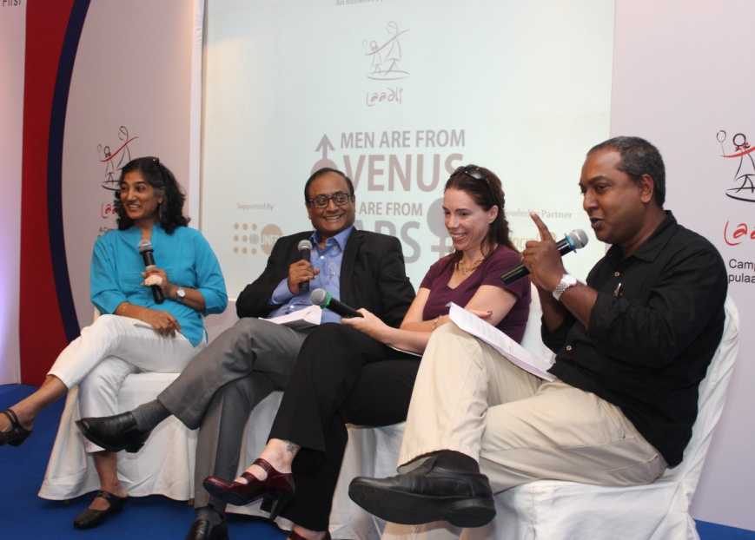
(L-R) Panelists- Ms. Geeta Seshu (Independent Journalist), Mr. Surojoy Banerjee (Director & Exec. V.P., RK Swamy BBDO) Ms. Heather Gupta (Chief Talent Officer, 120 Media Collective) moderatorMr. Gokul Krishnamurthy (Editor, Campaign India Magazine)
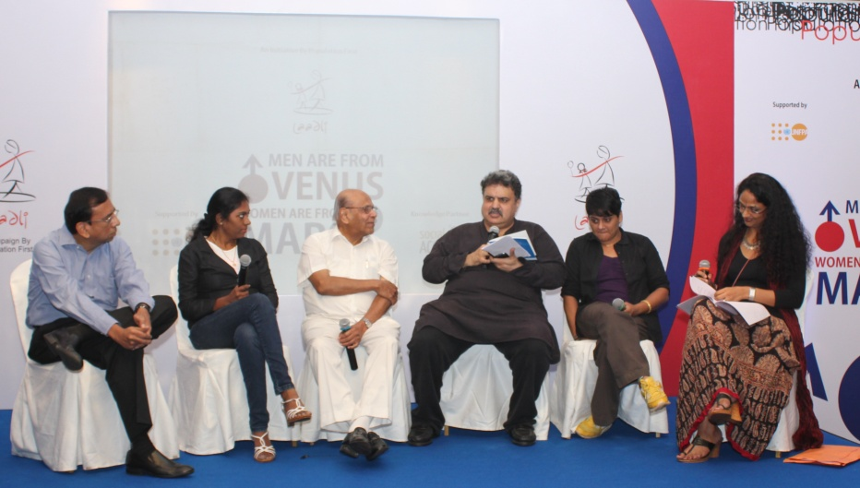
(L-R) Panelists - Mr. Partho Rakshit (Independent Marketing Cosultant), Ms. Prathyusha Agarwal (VP Marketing, HDFC Life), Mr. Bobby Sista (Exec. Trustee, Population First), Mr. Pradyuman Maheshwari (Editor-in-Chief & CEO, MxM India), Ms. Priti Nair (Director, Curry Nation) moderator Ms. Suneeta Rao (Spokesperson, Laadli Campaign)

The findings of the survey was then presented by Lynn Dsouza of Social Access Media and this formed the basis panel discussion ‘The yin and yang dynamics- the changing fabric of the Indian workplace’that followed. The panel comprised ofGeeta Seshu (Independent journalist and consulting editor of Hoot)Heather Gupta (representing the HR of Media)and Surajoy Bannerjee (Director and Executive President of RK Swamy BBDO) and it was moderated by Gokul Krishnamurthy of Campaign Magazine.The findings of the survey were discussed in detail with specific reference to some of the important issues raised.
After this the report “Drawing the Line: Creative Freedom vs Gender Sensitivity”(findings of the study of the complaints dealt with by ASCI-mentioned above) was presented by Dr Sharada. This was followed by a panel discussion titled ‘self regualtion a sustainable resolution’.The panelists were Mr Sista Executive Turstee Population First (formerly of Sista Ad Agency) Preeti Nair (founder curry nation) and Pradyuman Maheshwari (editor and CEO of MXM India) and Prathyusha Agarwal of (VP marketing of HDFC Standard LIC).Moderated by Sunita Raothe primary discussion was the Cases placed before ASCI and the decisions taken to see to what extent it was able to control the content of advertising.
Rating advertisements on gender
An interesting way in which Laadli has chosen to work towards more gender-sensitive ads is by assigning scores for gender-sensitivity to ads appearing in the print and electronic media, on a fortnightly basis. Dr.Sharada assumed this responsibility for rating ads for Campaign India magazine – the voice of India’s media, marketing and advertising community –
since August 2013. She rates ads on a scale of 1-10, 10 indicating the highest in gender sensitivity.
What engage readersare the reasons she attaches to each score. For instance, in the 23 August 2013 issue of the magazine, she gives the Parle Hide & Seek ad a score of six with the following explanation: “Showing the girl in a non-stereotypical way as indulging in an adventurous sporty action is refreshing.” And the Nazraana jewelry ad notches a high score of six with the following comment from Dr.Sharada: “Though this ad also uses marriage as the context for promoting the product, it gives a strong message with the groom’s family bringing the gifts for the bride’s parents and also making them feel comfortable. This is a welcome change, though I feel that associating jewelry with marriage fuels dowry demands which makes families view daughters as economic burden.”
On the same page as Dr.Sharada in Campaign India are two other prominent personalities from the ad world – also assigning gender sensitivity scores to the same bunch of ads. Comprehensibly, this idea has caught on and evoked good response from readers and the ad industry. It’s interesting to note how the same ad is rated differently by the three persons, and the comments are even more of a delight. Concludes Dr.Sharada, “Someonerecently told me how they look forward to getting the scores. I hope some people from ad agencies will pick up lessons from this page.”
Other stand-alone activities
Apart from these focused activities, the Laadli campaign has also included several other initiatives to reach the missive of gender equality to as many sections of society as possible, the principle behind this being that every drop matters, every effort counts. Here is a summary of these activities:
Laadli day celebration in Bombay Hospital

A Laadli Day celebration was suggested to Bombay Hospital doctors to which they readily conceded. Posters of 'Save Girl Child and Stop Sex Selection' were put up at Bombay Hospital, especially in the sonography department, on hospital information boards, and in corridors for one week, starting 9th June, the Laadli day. Through the display of posters, the message of ‘Saving the Girl Child’ was easily disseminated among all visitors of Bombay Hospital. Population First information brochure and bookmarks were also shared with doctors.

Laadli day celebration inLifestyle Stores

LaadliDay was also celebrated by Lifestyle Stores on 9th of June, at the request of Population First.Badges with the message to save the girl child and promote gender equality were printed and distributed by Population First to six Lifestyle Stores across Mumbai. On 9th June, all the employees of Lifestyle Stores supported the cause “Save the girl child” by wearing these badges.

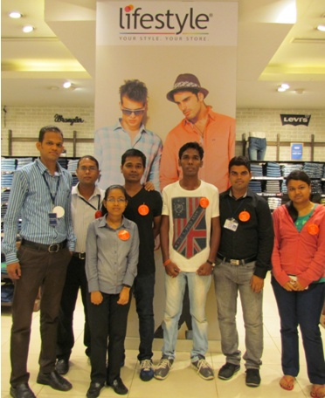
Staff of Lifestyle Mall (Goregaon) sporting Laadli Badge

Exhibition of Population First products at L&T Finance Ltd.
As a part of the Joy of Giving Week, L&T Finance invited Population First to set up a stall at their Kalina office on 7th October 2013 for an exhibition-cum-sale of its products.Population First distributed its products like mugs, T-shirts, bookmarks, cards, and notepads and also handed out brochures and bookmarks which carried the demand for a “JUST AND EMPOWERED NATION FOR WOMEN.”
Participation in Charity Melaat Trident Hotel
Population First was invited to join in a charity mela held by The American Women's Club on 30th November 2013 at Trident Hotel, BKC. The Laadli team saw this as an opportunity to spread its message on gender sensitivity and enlighten people about its activities aimed at raising the bar on gender equality. They put up a stall with their advocacy material and grandly advertised the program ‘Laadli,’ attracting over 5000 eyeballs.

Participation in NGO symposium on "New Media and Women Development”at Whistling Woods International

The media students of Whistling Woods International organized a NGO Symposium with the principal theme "New Age Media and Women Development" on October 18. It was an expression of the students’ commitment to actively support the nation’s endeavor to create a gender-just society. Population First was invited to be a part of the same and readily took part in it. The symposium discussed three sub-themes:
- Social media and education of the girl-child
- Internet – a source of women empowerment
- Digital media – a guide to women's health and nutrition
SexualViolence Research Initiative
Resource material on ‘Sexual Violence’ collected by Population First was submitted to ‘Sexual Violence Research Initiative,’ an NGO of Africa, for placing it on their website.
Celebrating womanhood through a social media campaign
In consonance with Population First’s credo of changing mindsets through positive initiatives, National Creative Director of leading advertising agency Leo Burnett (LB), K. V. “Pops” Sridhar, conceptualised a positive campaign called ‘I am Laadli’ (IAL)for the International Women’s Day on March 8, 2013. The campaign was conceived as a celebration of women by women. As India is rapidly getting more wired with the total number of internet users expected to cross 125 million soon, a web-based campaign was preferred and Facebook (FB), and Twitter was selected for the “I am Laadli’ campaign.

Many promotional activities were planned through various media. True to Population First’s maxim – influence the influencers – a 30-second film showcasing celebrities from all walks of life promoting the campaign was filmedby the Leo Burnett team. Population First got on board noted National Award-winning director GauriShinde, popstar SuneetaRao and actress RenukaShahanefor the film. The quality of the Leo Burnett 30 second film was such that it could then be broadcast on various TV channels/radio stations on the special day.
Radio stations were invited to participate in the campaign by addressing all women as ‘Laadli (name)’ and requesting women listeners to call in to proudly declare why they are laadlis. The Laadli film was also broadcast on the DNA home page. The film was also posted on our YouTube account (http://www.youtube.com/watch?v=8xPC5w3eaZA).The Petticoat Journal, MxM Media and Exchange4Media covered the story. Carol Andrade, Editor of the Afternoon D&C, proudly affixed ‘Laadli’ to her by-line.

About 100 people had downloaded the FB app by lunchtime on 8th March. The IAL campaign was launched to initially activate and peak on one special day and so it did on Twitter.However, it was extended till the end of the month to take advantage of the efforts and resources committed to it by all those involved. By the end of March, there were around 320 users of the FB app and around 500 tweets. The analytics on the sentiment and buzz for the hashtag showed the majority of the tweets were slightly more positive than neutral .

Conclusion
The commitment and enthusiasm of the Population First’s team to take the campaign ahead is blazingbright as ever. Their motivation – the tangible and intangible effects of this campaign that they witness every day.A new Insurance ad in the paper urging the readers to save and plan for their son’s marriage and daughter’s education.More articles with gender slant. More students awaking to gender and more heated gender debates in classrooms.More women breaking into new atypical professions and proving their mettle.More celebrations upon the birth of a girl-child.
To quote Frederika Meijer, UNFPA representative, India and Bhutan, “More and more media and advertising professionals have now started filtering their work by using a gender sensitive lens. Television commercials in India have undergone a silent but significant shift in their portrayal of girls and women. The focus on gender issues in the electronic and print media has evolved from being sensational to that which is gender-sensitive. Budding journalists are seen reporting with a perspective that was rarely reflected before. In fact this trend has also extended to the new media. Age-old gender mind-sets are being demolished in more ways than one. As voices that challenge gender stereotypes in the mainstream media gain strength, Laadli watches on with a sense of pride.”

Population First
Shetty House, 3rd Floor
101 Mahatma Gandhi Road
Fort, Mumbai – 400 023
Tel. 91 22 22626672
info@populationfirst.org

